**Data Quality Report**

**1. Summary of the dataset**

Dataset *card transactions* contains 10 variables and 96,708 observations. The 10 variables are **'Recordnum', 'Cardnum', 'Date', 'Merchantnum', 'Merch Description', 'Merchant State', 'Merchant Zip', 'Transtype', 'Amount', 'Fraud'.**

Below are summaries of numeric variables and non-numeric variables.

**Summary of Numeric Variable**

**../../../../螢幕快照%202018-04-05%20上午1.59.43.png**

**Summary of Non-Numeric Variables**

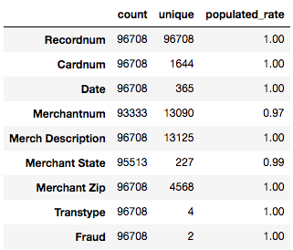

**2. Detailed information for Each Field**

|  |  |
| --- | --- |
| *Field Name* | *Description* |
| Recordnum | Index of the dataset |

|  |  |
| --- | --- |
| *Field Name* | *Description* |
| Cardnum | Credit card number of the transaction |

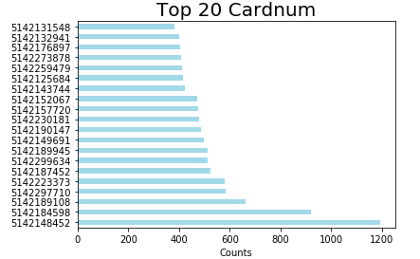

|  |  |
| --- | --- |
| *Field Name* | *Description* |
| Date | Dates of transactions |

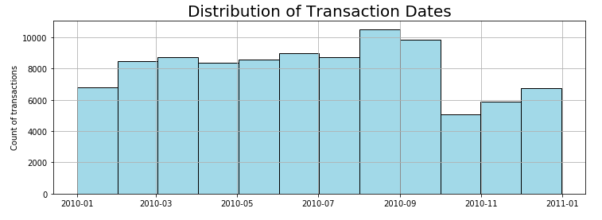

|  |  |
| --- | --- |
| *Field Name* | *Description* |
| Merchantnum | Unique numbers of transaction merchants |

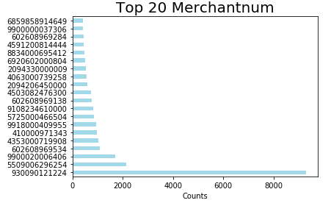

|  |  |
| --- | --- |
| *Field Name* | *Description* |
| Merch Description | Descriptions of transaction merchants |

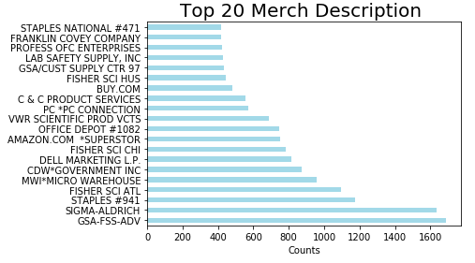

|  |  |
| --- | --- |
| *Field Name* | *Description* |
| Merchant State | State of transaction merchants |

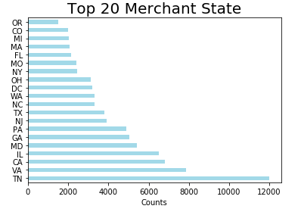

|  |  |
| --- | --- |
| *Field Name* | *Description* |
| Merchant Zip | Zip codes of transaction merchants |

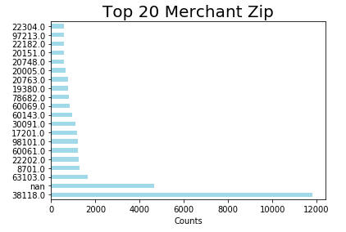

|  |  |
| --- | --- |
| *Field Name* | *Description* |
| Transtype | Types of transactions |

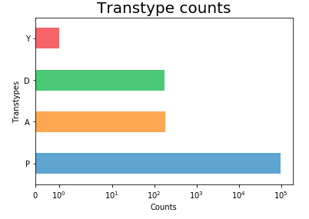

|  |  |
| --- | --- |
| *Field Name* | *Description* |
| Amount | Amount of transactions |

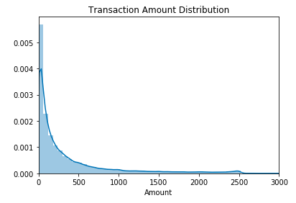

**NOTE**

Record **52593** is an outlier in **Amount**. The reason of its high **Amount** value is because the transaction was executed with Mexico Pesos.

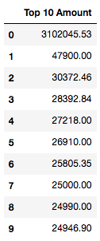 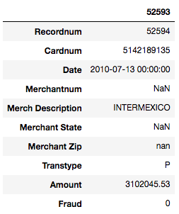

|  |  |
| --- | --- |
| *Field Name* | *Description* |
| Fraud | Whether a certain record is a fraud or not. |

